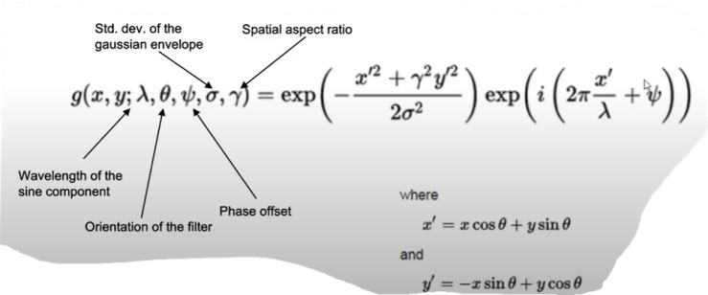 $g\left(x,y;λ,ϴ,ψ,σ,γ\right)=\exp\left(-\frac{x^{'2}+γ^{2}y^{'2}}{2σ^{2}}\right)exp⁡(i\left(2π\frac{x^{'}}{λ}+ψ\right))$

λ – Wavelength of the sine component

ϴ - Orientation of filter

Ψ- Phase offset

- Std. dev. Of the gaussian envelop

. $γ$– Spatial aspect ratio

Where,

X’ = xcos $ϴ$ +ysin $ϴ$

Y’ = -xsin $ϴ$ +ycos $ϴ$